Chanderi fabric is produced by weaving in silk and golden Zari in the traditional cotton yarn that results in the creation of the shimmering texture. ... This fabric can be classified into three types – Chanderi silk cotton, pure silk and Chanderi cotton.
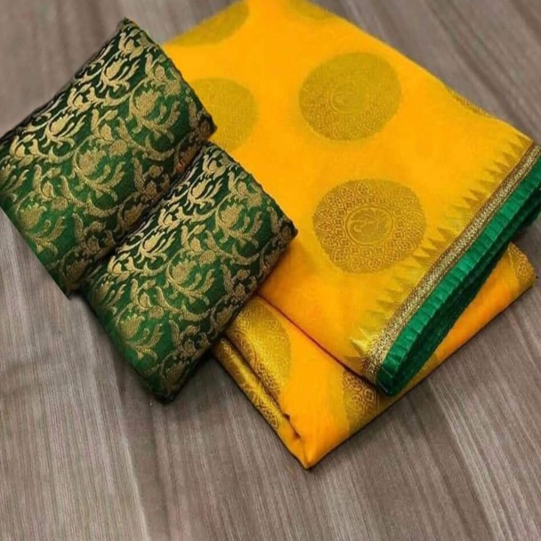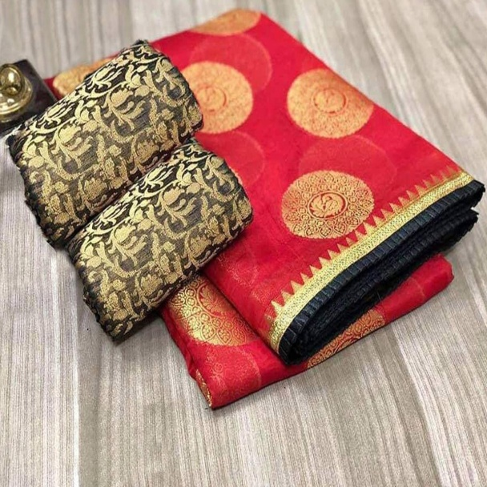
- What is Chanderi silk sarees?
Chanderi sarees are produced from three kinds of fabric: pure silk, Chanderi cotton and silk cotton. ... The saris are among the finest in India and are known for their gold and silver brocade or zari, fine silk, and opulent embroidery.
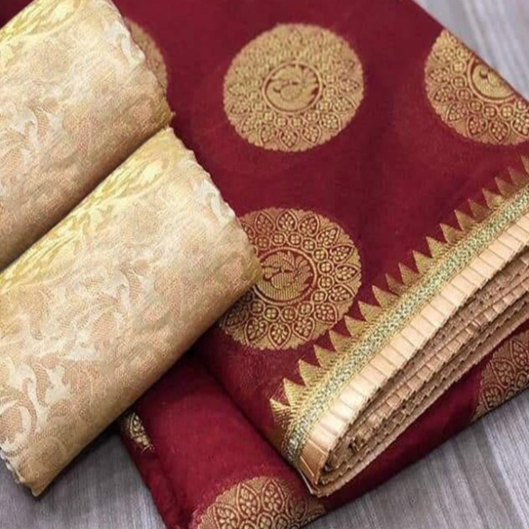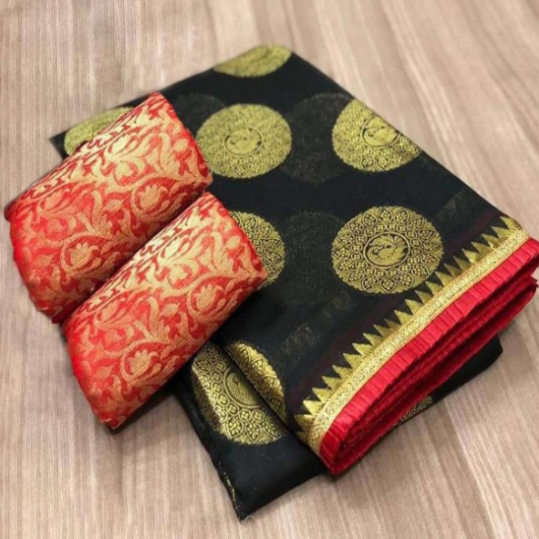

- Where are Chanderi sarees made?
Chanderi sari is a traditional sari made in Chanderi, Madhya Pradesh, India.
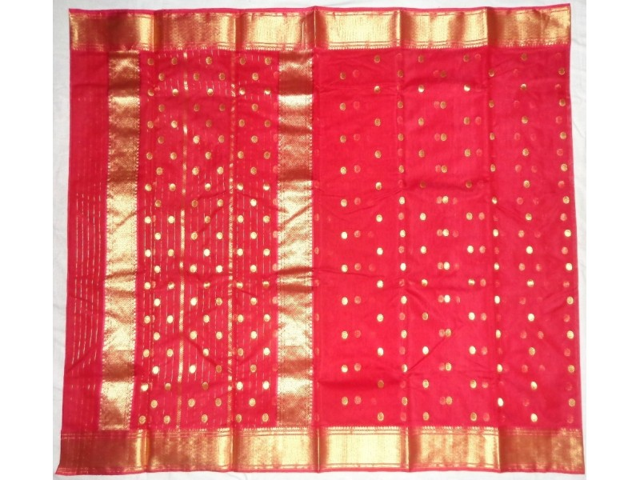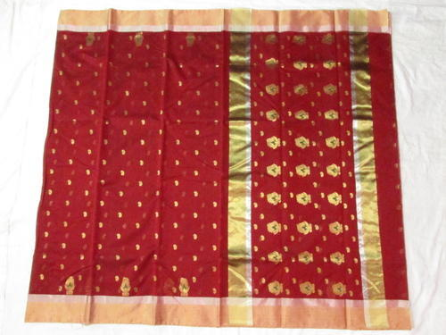

- What are type of Chanderi Saree?
Chanderi sari is a traditional sari and there are several verities

- Chanderi Silk Cotton Handloom (Price :: Rs.1899/- to Rs.3299/-)

- Wooven Design Chanderi Saree (Price :: Rs.850/- to Rs.1499/-)
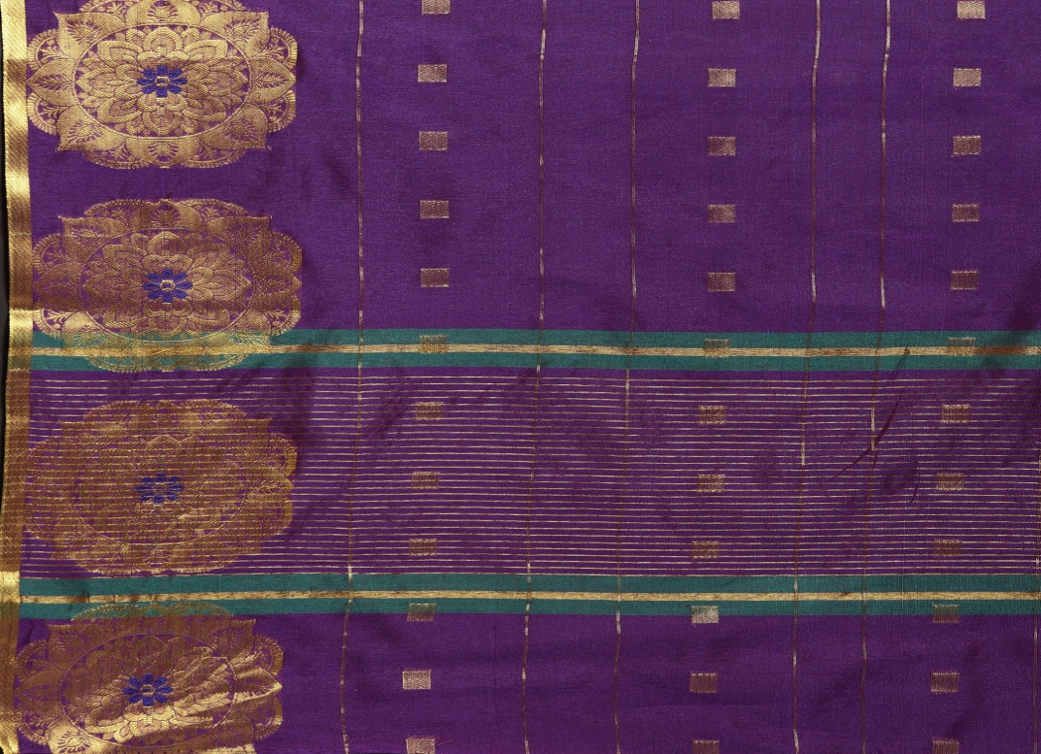

- Embroider Chanderi Saree (Price :: Rs.1299/- to Rs.2499/-)
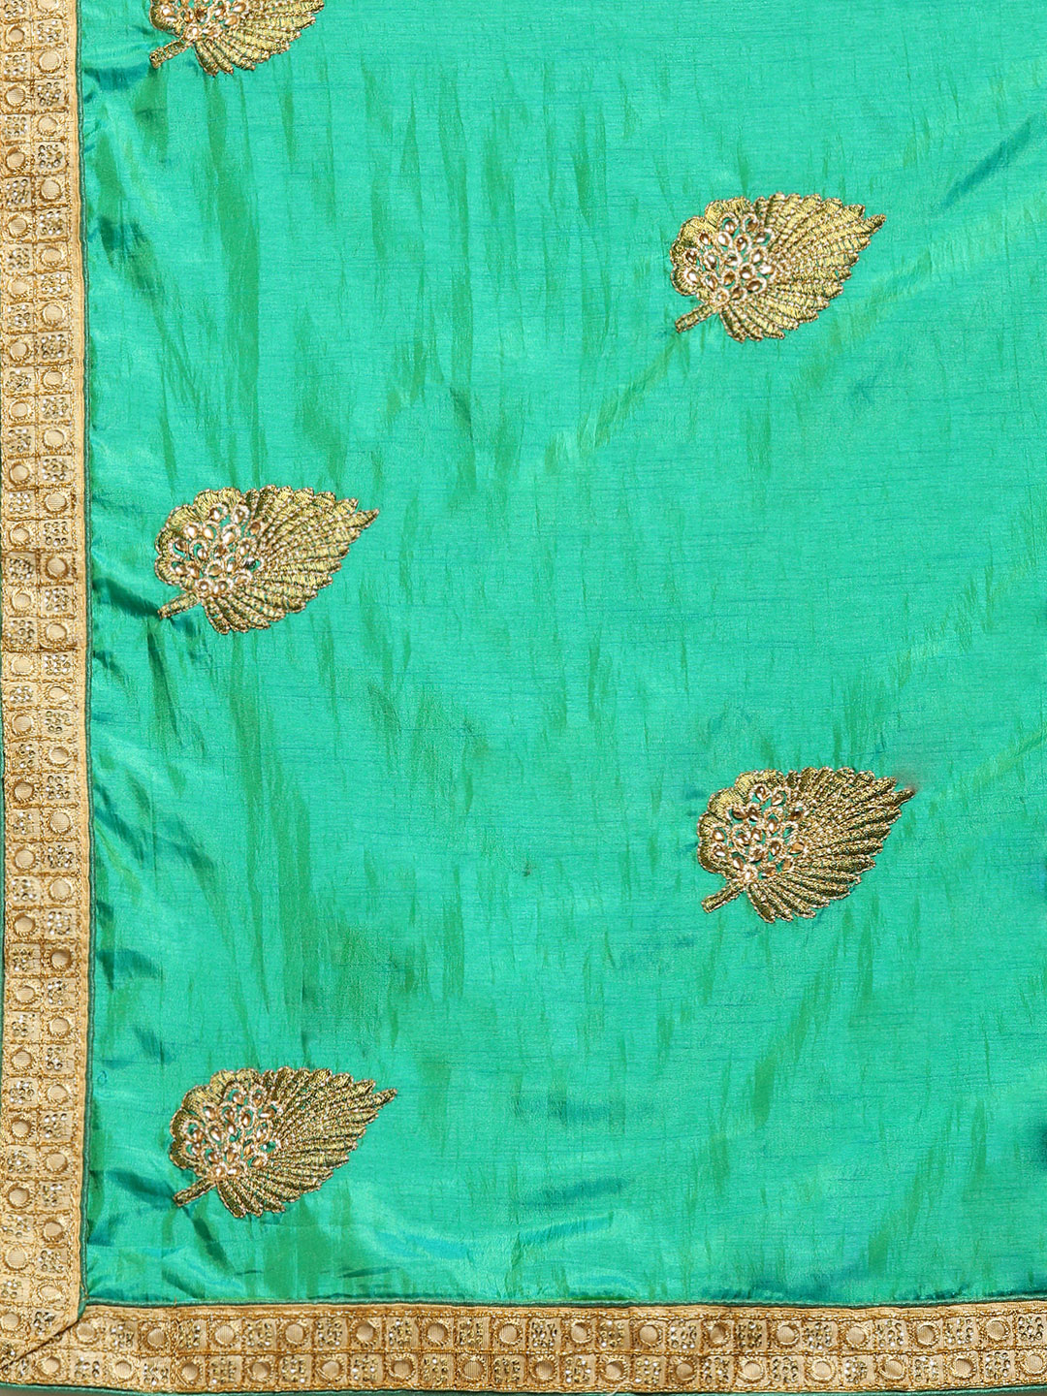

- Solid Chanderi Saree (Price :: Rs.750/- to Rs.1699/-)
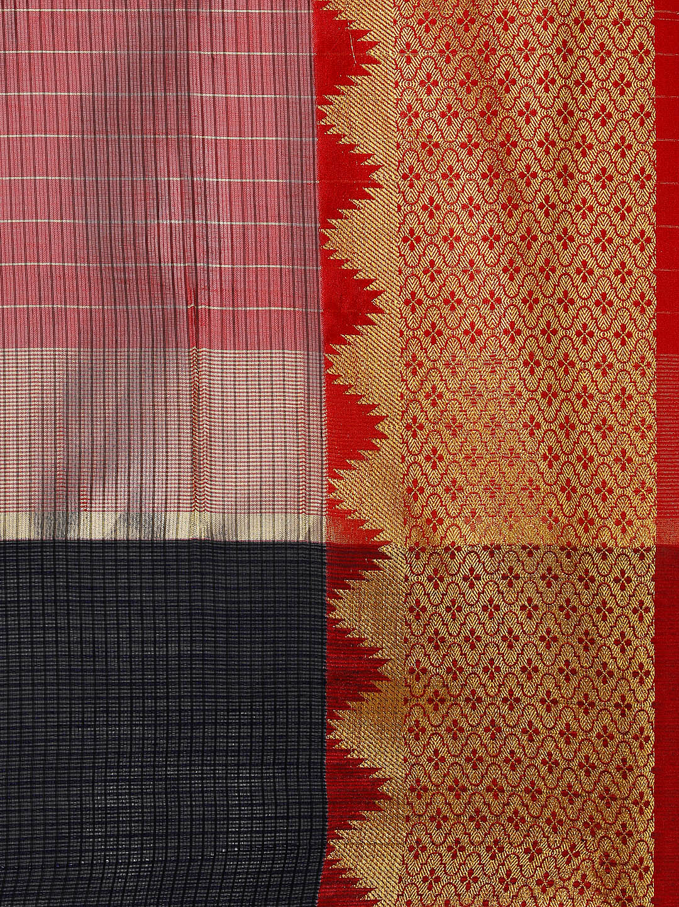

- Silk Cotton Chander Saree (Price :: Rs.750/- to Rs.1699/-)
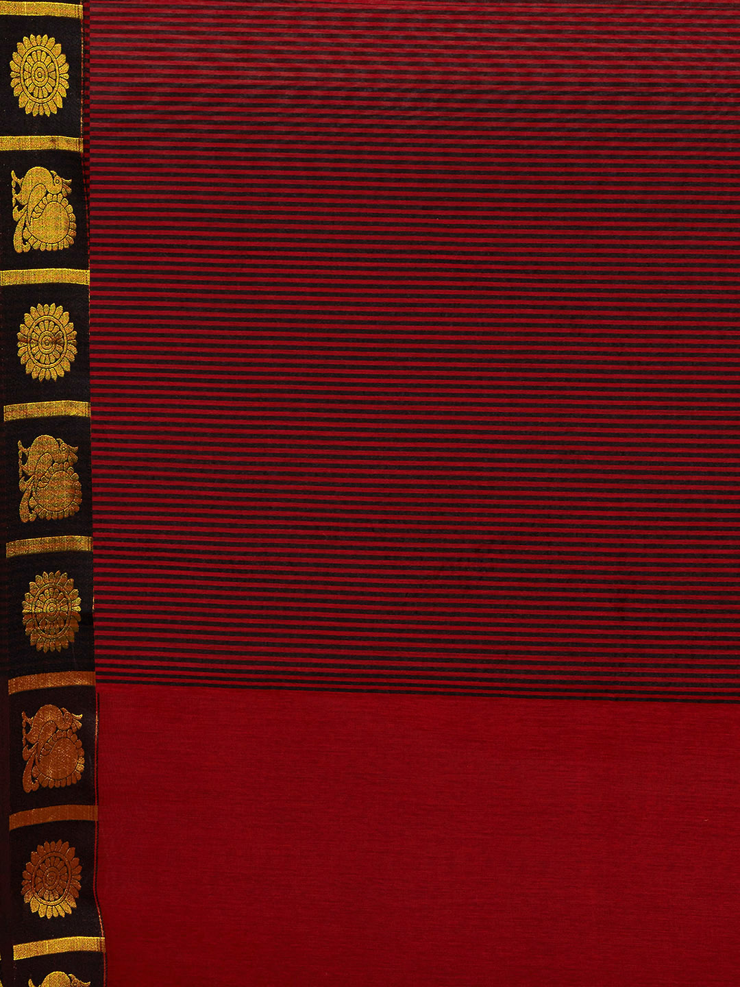

- Stripped Chanderi Saree (Price :: Rs.700/- to Rs.1299/-)
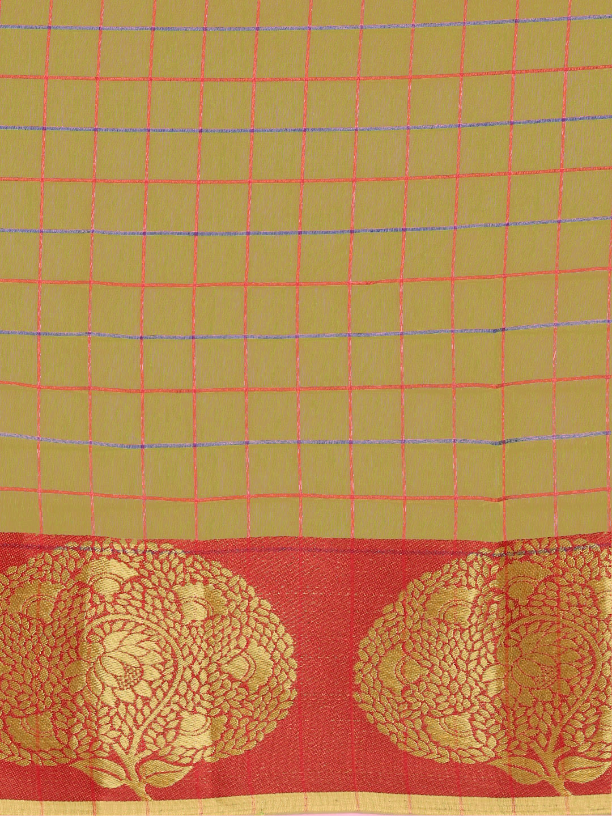

- Meenakari Chanderi Saree (Price :: Rs.1199/- to Rs.2899/-)

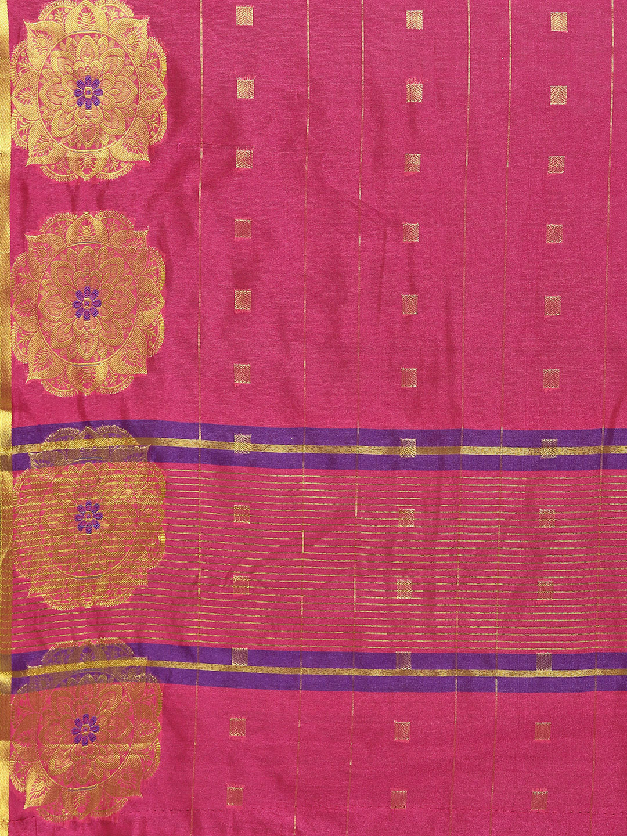

- Hand Wooven Chanderi Saree (Price :: Rs.11599/- onward)
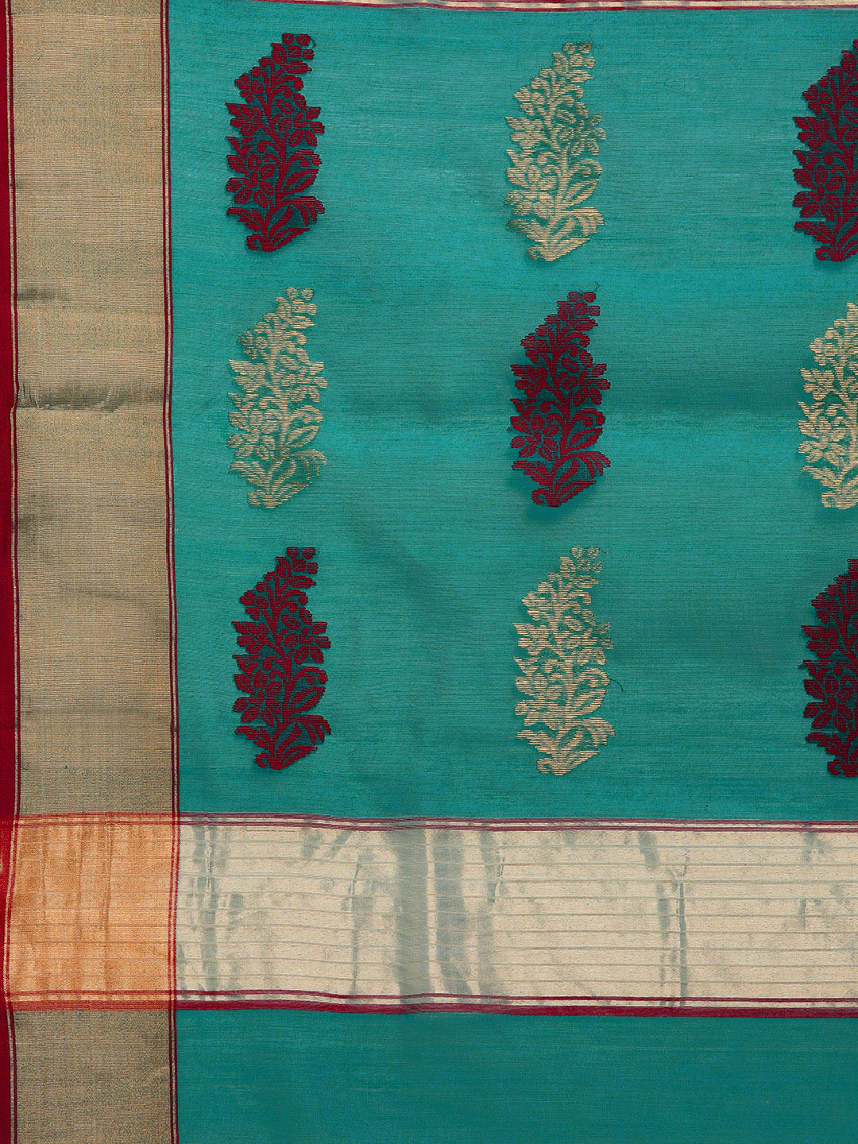

- Is Chanderi silk good for summer?
Chanderi, is a lightweight fabric that makes it apt for summer. It is also available in bright colors and has a slight sheen to it which makes it wearable for parities as well. Chanderi is a blend of cotton with light silk and some zari. ... The fabric is wearable and also looks good

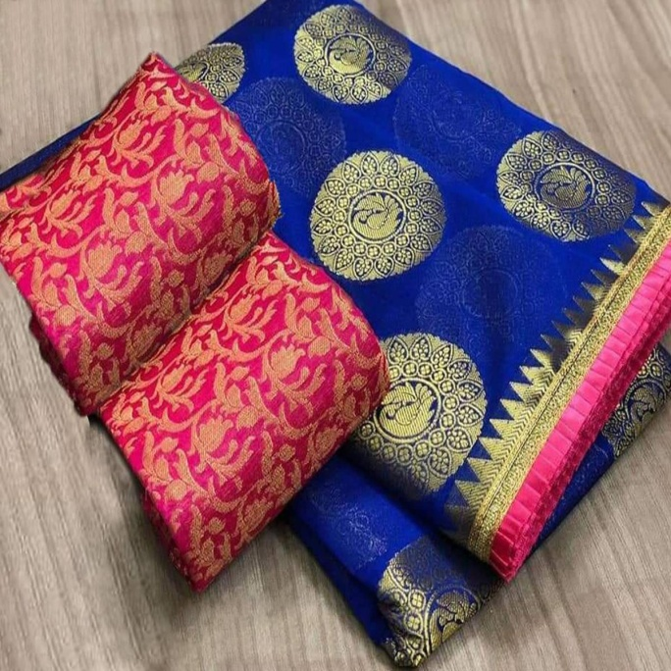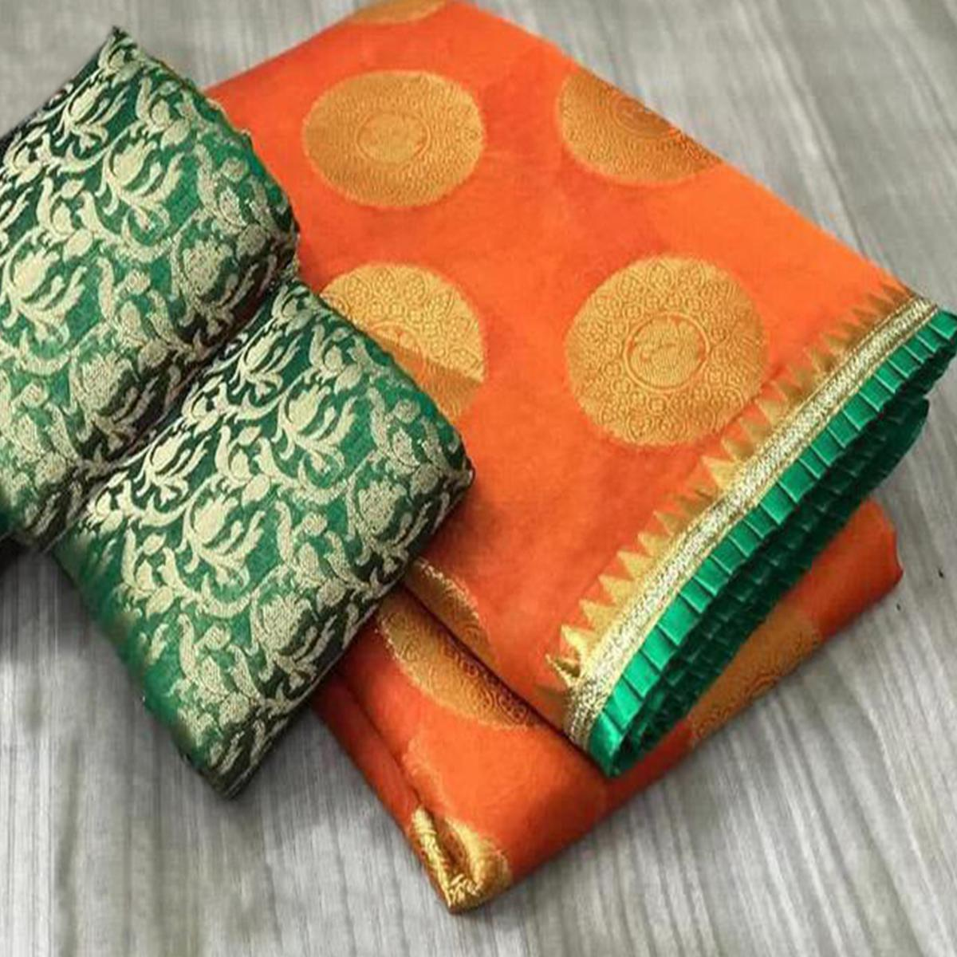
- Can Chanderi be washed at home?
Use a mild detergent for washing and wash it in cold water. Do not expose Chanderi fabric to sun. Dry in shade, always on the reverse side. Chanderi cotton suit with dupatta and sarees should never be ironed in folds.
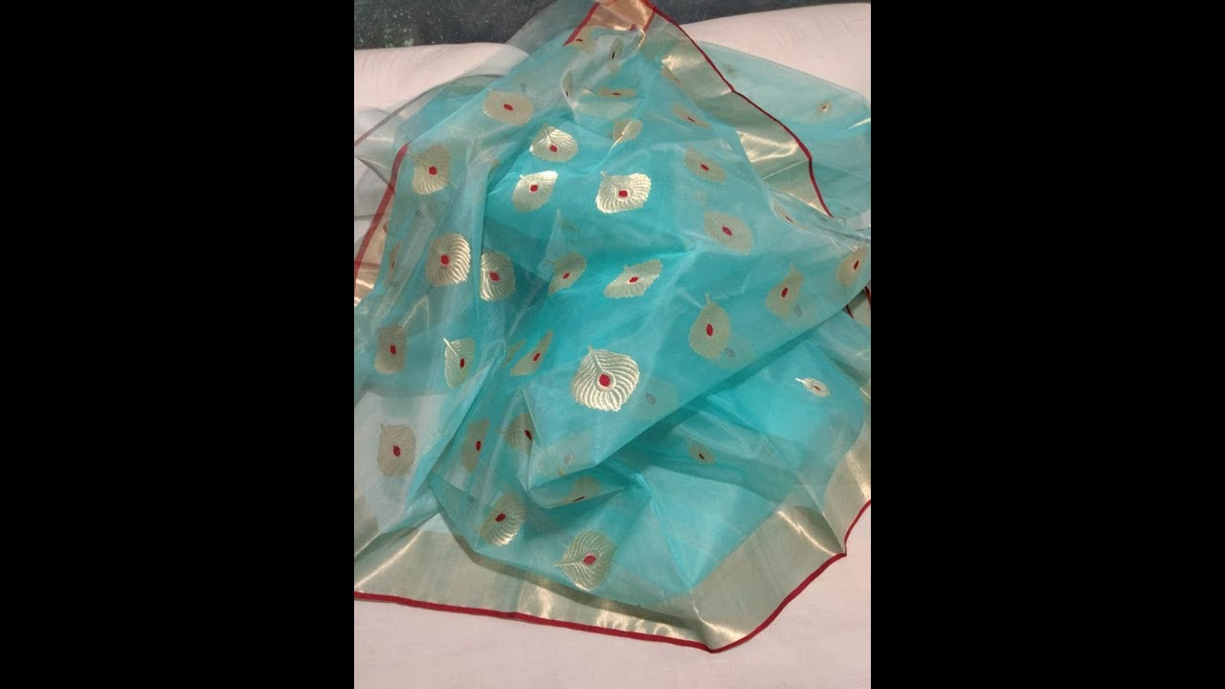
Pure Katan Chanderi Silk Sari

- What is Chanderi famous for?
Chanderi, which is amongst the best known handloom clusters, occupies a special place because of its centuries old weaving specialty of producing finely textured fabrics of silk and cotton embellished with zari woven work, and more specifically because of its saris that have been patronized by royalty.

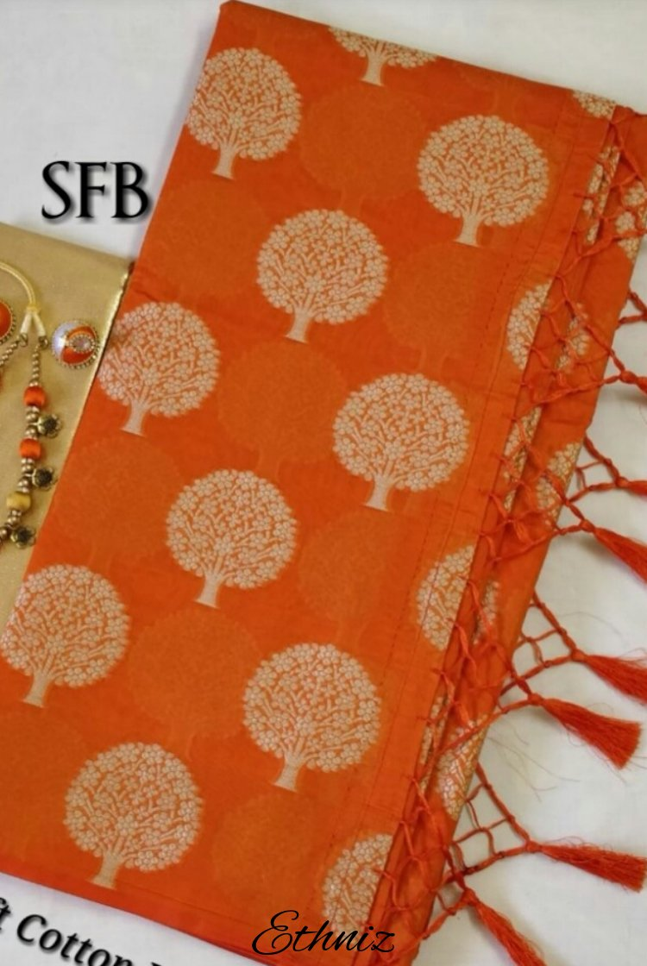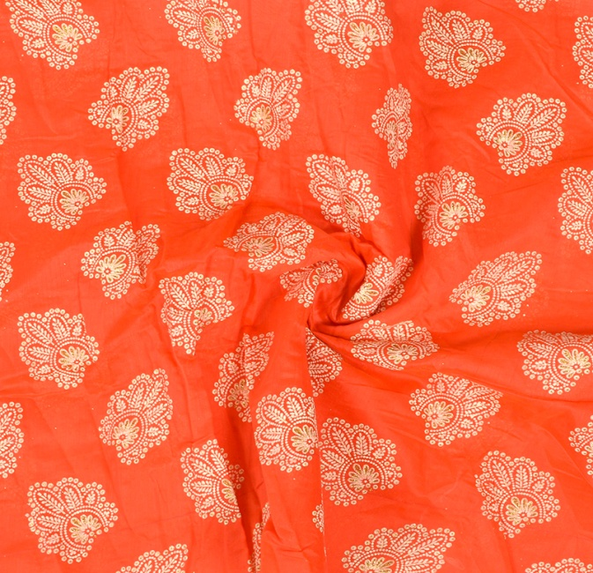

Price Range :: Rs.850/- – Rs. 8898/- depending upon the looks,design,colour and material

